**Developing a multi-functional test stand**

A thesis written at

**Magna Electronics**

and submitted to

**KETTERING UNIVERSITY**

in partial fulfillment

of the requirements for the

degree of

**BACHELOR OF SCIENCE IN ELECTRICAL ENGINEERING**

by

**jASON M. JUDSON**

Author

Employer Advisor

Faculty Advisor

**DISCLAIMER**

This thesis is submitted as partial and final fulfillment of the cooperative work experience requirements of Kettering University needed to obtain a Bachelor of Science in Electrical Engineering Degree.

The conclusions and opinions expressed in this thesis are those of the writer and do not necessarily represent the position of Kettering University or Magna Electronics, or any of its directors, officers, agents, or employees with respect to the matters discussed.

**PREFACE**

This thesis represents the capstone of my five years combined academic work at Kettering University and job experience at Magna Electronics. Academic experiences in Kettering University proved to be valuable assets while I developed this thesis and addressed the problem it concerns.

Although this thesis represents the compilation of my own efforts, I would like to acknowledge and extend my sincere gratitude to the following persons for their valuable time and assistance, without whom the completion of this thesis would not have been possible:

1. Mike Myers – Validation Engineer
2. Joe Borowitz – Validation Engineer
3. Brian Hoover – Validation Software Engineer
4. Matt Keller – Validation Manager
5. Jeff Sparks – Senior Engineering Technician
6. Judy Schneider – Engineering Technician

**TABLE OF CONTENTS**

DISCLAIMER 2

PREFACE 3

LIST OF ILLUSTRATIONS 6

I. INTRODUCTION 7

Problem Topic 8

Background 8

Criteria and Parameter Restrictions 9

Methodology 10

Primary Purpose

Overview

II. CONCLUSIONS AND RECOMMENDATIONS 14

Conclusions 14

Recommendations 18

     

III. **Error! Reference source not found.** **Error! Bookmark not defined.**

     

     

     

IV.

     

REFERENCES

GLOSSARY

APPENDIX: ABET PROGRAM OUTCOMES

(or, if more than one appendix, use the following)

APPENDICES

APPENDIX A:      

APPENDIX B: ABET PROGRAM OUTCOMES

### LIST OF ILLUSTRATIONS

**Figures Page**

1. Figure 1: Deployable Running Board Diagram 7

2. Comparison of what exists and what is needed 9

3. DRB Controller Representative Circuit 23

**Appendices**

A-1.      

A-2.      

B-1.      

B-2.      

**Tables**

1. Hardware Cost Analysis 17

2.      

**Appendices**

A-1.      

A-2.      

# INTRODUCTION

The life cycle of an automotive product has a number of distinct stages with a specific purpose and goal. The Process Validation Stage is the final stage of testing that a product must go through before it can be shipped to the customer. The goal for this stage is to ensure that the production process meets the quality standards determined by the customer and that the product can endure several tests that are designed to expose the product to various environmental conditions. These conditions can have devastating effects on the life span of the product and functionality. The majority of this document pertains to the Deployable Running Board(DRB) controller produced by Magna Electronics and the preparation involved to accomplish this environmental testing in a timely manner. Figure 1 shows the base concept behind the DRB and its intended purpose. The module is supposed to receive a command when the door of the vehicle is opened and extend the armature allowing the user to step onto the running board.

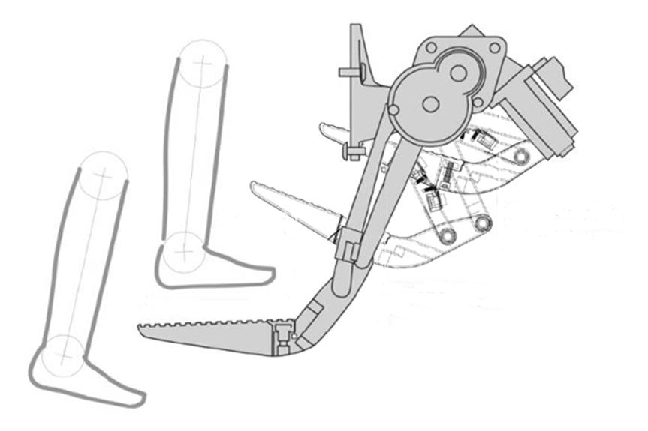

Figure : Deployable Running Board Diagram

## Problem Topic

The electrical test stands for the Deployable Running Board (DRB) Program do not have the capability to complete environmental testing within the desired timeline. A delay in the testing timeline due to the outdated test stands will increase the overall cost of the environmental testing and decrease product profitability.

## Background

In the first quarter of 2013, Magna Electronics restructured the company into two different engineering divisions. The choice was also made to split products between these two divisions with the first division acquiring the most lucrative product and the second division acquiring the rest. As a result, this product split would require the DRB program to be manufactured in a different facility and qualifies as a change in the manufacturing process. A re-validation would be required by the customers before they will accept the finished products.

The existing test stands have limited functionality and capacity that will not meet the required timeline to reduce unnecessary costs. The functionality of one stand can test one part type out of five and the other can test two out of five. Only 60% of the part types are covered between the two stands. Figure 2 shows a graphical representation of the current configuration versus the desired configuration that was pre-determined by the Validation Engineering Manager. The capacity of each stand is limited to eight modules simultaneously but some tests require 18 modules to be operated during tests. The current setup would require the tests to be run three separate times to satisfy the requirements. The two test stands must be re-designed to accommodate the improved functionality and increased capacity to meet the criteria that is needed to complete the environmental testing in a timely manner.

GMT900 & K2XX (GM)

8 Modules

Ford  
JLR

8 Modules

Test Stand 1

Test Stand 2

Existing Configuration

Desired Configuration

GMT900 K2XX

Ford

JLR

Toyota

9 Modules

GMT900  
K2XX  
Ford  
JLR

Toyota

9 Modules

Test Stand 1

Test Stand 2

Figure : Comparison of what exists and what is needed

## Criteria and Parameter Restrictions

* Add supporting architecture to cover 100% of all DRB module types to include the following major customers:

Ford

General Motors

K2XX Platform

GMT900 Platform

Jaguar Land Rover (JLR)

Toyota

* Increase capacity from 8 modules per test stand to 9 modules per test stand
* Minimize cost of re-design to keep within $15,000 budget
* Update test stand documentation to a professional level with a user friendly interface

## Methodology

The limitation of resources and time required a systematic approach to problem solving that was vital to the success of the project. The systematic approach in this case involved understanding the function of an existing test stand instead of designing and building from scratch. The following approach was used to complete the project:

1. Understand how the existing test stands function to apply concepts on new design
   1. Shadow the lead engineer to understand the interaction between the module and test stand
   2. Convert existing documentation into a user friendly format to get an insight on the existing construction
   3. Examine existing test stands to understand the wiring, layout, and test function
2. Understand the module functionality to discern testing principle
   1. Examine module schematics to secure a list of all inputs and outputs to be tested
   2. Meet with software lead to understand normal operation of each module type
   3. Contact lead electrical designer to gather load characteristics and simulate real world application
3. Gather specific upgrade criteria developed by Validation Manager to avoid deviation from final goal
4. Research implementation options to expand capability and capacity of test stands
   1. Meet senior Validation Engineers to accumulate possible COTS(Commercial Off The Shelf) solutions
   2. Determine serviceability of parts from existing test stand to remain within budget
5. Develop purchasing list and total cost to evaluate budgeting concerns
   1. Compare and contrast cost solutions that meet upgrade specifications to single out   
      best solution
   2. Construct a BOM(Bill of Materials) and vendor quotes to achieve exact cost of upgrades
   3. Submit a PO(Purchase Order) to be approved by the Validation Manager and the Program Manager
6. Re-design test stands to accommodate chosen method of implementation
   1. Cross reference inputs and outputs of all module types to compose common interfaces to the test stand
   2. Reconfigure wiring and layout to contain upgrades while improving accessibility for maintenance
   3. Construct pin map for the Validation Software Engineer to avoid delays in software completion date
7. Begin constructing new test stands to allow time for confidence testing
   1. Submit ESR(Engineering Service Request) to acquire needed technicians
   2. Update new and accurate documentation to facilitate readability and expandability
8. Begin confidence testing of completed test stand to verify functionality
   1. Test each part location individually to avoid confusion on multiple failure modes
   2. Fix failure modes as they appear to eliminate further complications
   3. Test all locations simultaneously to confirm increase of capacity
   4. Run mock testing to build confidence of overall design
   5. Make final adjustments to hardware or software if any issues surface during confidence testing
9. Duplicate the fully functional and fully tested stand and complete confidence testing
10. Begin Environmental Testing

# TEST STAND DEVELOPMENT

Developing a test stand in most conditions involves the understanding of the module under test but in this case it also required a deep understanding of the existing test stands. The first step was to gather all the known resources for the project. The purpose for this is to recognize any limitations set by the resources available. The next part is creating a high level architecture that can satisfy all the requirements and finally the construction and confidence testing of the fully assembled test stand. The nature of this project had an added effort at every stage with extra variables.

## Gathering Resources

The first step of this project was to gather all the information and resources involved with the current test stands and understand exactly how they functioned. The purpose for this was twofold, one for discovering how the stands were assembled and the second for an accounting of all available resources. The most important part was to gather all known resources including hardware, documentation, people, and anything else that may have provide insight to the project.

The hardware was the resource that proved to be the least difficult to acquire and included the original test stands that barely functioned enough to complete the previous environmental testing. The testing was not accomplished in an efficient manner. The original test cycles needed to be ran three times because of these limited resources. The first challenge for this project was to comprehend how the stand interacted with the modules under test.

The existing documentation was inadequate to the point that an experienced technician could not have a basic understanding of assembly, so the only immediate resource available was the engineers that built the stand. Unfortunately, the hardware engineer was “let go” shortly after the beginning of this project. The software engineer, however, was still available as a primary resource. The software engineer was able to bring the most important aspect of the interaction between the module and the stand and to gain further insight; research was invested in the composition of the hardware and software of the module. The hardware of the module provided an insight into the hardware interface of the test stand while the software of the module gave an insight into the capabilities of that hardware. The last aspect to give insight is the characteristics of the load interface. The type of measurement needed had already been established through other investigations but what about the duplication of real life scenarios? Time was also invested trying to understand how to simulate real part life conditions and provided valuable insight to even more hardware of the test stand. The collection of all resources and insights provided a clearer understanding of how the stand functioned and interacted with the modules but was limited to the hardware of the stand, documentation of the modules, and the insight of the software engineer.

Since the budget for this upgrade was so limited, the upgrade of the two stands would require the reuse of most of the components that had been used in the old stands.

## Test Stand Layout

The most important part of the entire project was having a concise and cohesive architecture to reference during development. Without a good architecture, the development and construction of the stand could have delays from last minute design changes. This could have a detrimental effect on the main goal of the project and delay completion of the testing.

#### Consolidation of Signals

#### Assembly and Confidence Testing



Figure : Test Stand Architecture

# CONCLUSIONS AND RECOMMENDATIONS

The main concern with the DRB program was the ability to complete a plant transfer in a timely manner. Because of underperforming test stands with limited capabilities the aggressive timing could not be met. The goal of this project was to upgrade the test stand while taking the opportunity to expand the functionality. Through the course of this project many changes were made to the original plan (See Appendix A) but the end design still allowed for greater flexibility and expandability.

The recommendations provided are idealistic in nature with the viewpoint that a design is done once and reused multiple times. These designs have a very large upfront cost in both money and time but will save money due to the reduction of the total resources needed to accomplish the same set of tasks.

## Conclusions

* The new test stand can support all module types with the exception of the Toyota variant.
  + The stand has been rigorously tested for all module types by the Validation Team.
  + The stands have also completed validation testing that will be sent to multiple customers (FORD, JLR, GMT900, K2XX)
* The stand is also fully capable of testing nine modules simultaneously as opposed to its previous capability of eight
  + The stand has been rigorously tested for all part locations by the Validation Team. Further proof can be seen in Appendix B
  + The stand has completed all of the environmental testing and has reduced the number of test cycles needed by 30%
* The entire project was just barely over the $15,000 budget completed testing before the target completion date of October 20, 2013.
  + The total dollar amount spent was $717.27 over budget *See Table 1*
  + The environmental testing completed the last test on October 08, 2013

Table 1: Hardware Cost Analysis

|  |  |  |  |  |
| --- | --- | --- | --- | --- |
| **Manufacturer Part#:** | **Description:** | **Quantity:** | **Unit Cost:** | **Total:** |
| 778739-01 | NI PXI-2529 | 2 | $2,240.00 | $4,480.00 |
| 196762-01 | NI TB-2636 | 2 | $287.00 | $574.00 |
| 779630-01 | NI PXI-6229 | 1 | $1,015.00 | $1,015.00 |
| 779756-01 | NI PXI-1033 Chassis | 2 | $1,139.00 | $2,278.00 |
| 778948-01 | PXI-103x and PXIe-107x Rack Mount Kit | 2 | $170.00 | $340.00 |
| 192061-02 | SHC68-68-EPM Shielded Cable | 4 | $139.00 | $556.00 |
| 778933-01 | PXI Filler Panel | 2 | $52.00 | $104.00 |
| 206226-1 | 500 Ohm Metal Film Resistor | 100 | $0.13 | $13.10 |
| HSMS-2822-BLKG | 15V Schottky Diode | 50 | $0.64 | $32.15 |
| 206837-1 | 24 pin Amphenol Connector | 50 | $4.30 | $215.00 |
| 206226-1 | 7 pin Amphenol Connector | 50 | $4.75 | $237.50 |
| 206227-1 | 7 pin Amphenol Panel Connector | 3 | $5.23 | $15.69 |
| 206838-1 | 24 pin Amphenol Panel Connector | 5 | $4.79 | $23.95 |
| 211825-1 | 13 pin Amphenol Panel Connector | 10 | $8.83 | $88.30 |
| PA-1102-BT | 2 Rack Unit Panel | 2 | $18.20 | $36.40 |
| G7L-1A-BUB-J-CB-DC12 | Omron 12VDC 30A Relay | 1 | $18.43 | $18.43 |
| HWS30-5/A | TDK Lambda 5V 6A Power Supply | 1 | $54.54 | $54.54 |
| HWS30-12/A | TDK Lambda 12V 2.5A Power Supply | 1 | $54.54 | $54.54 |
| 47065T167 | Aluminum Extrusion 1.5" x 3" | 4 | $67.30 | $269.20 |
| 47065T16 | End Cap for 3" Aluminum Extrusion | 6 | $1.80 | $10.80 |
| 2834T34 | 3" Rubber Wheel Caster | 4 | $10.65 | $42.60 |
| 47065T19 | Aluminum Extrusion 90 Degree Bracket | 12 | $6.94 | $83.28 |
| 8975K238 | Aluminum Extrusion 1" x 2" | 2 | $45.39 | $90.78 |
|  | Wire |  |  | $1,831.29 |
|  | Crimp Tool | 1 |  | $1,425.00 |
|  | Wire |  |  | $1,827.72 |
| **Total** |  |  |  | **$15,717.27** |

## Recommendations

*Redesign module interface circuitry*

Design high impedance interface circuitry to reduce the effect of the monitoring circuits on the module operation. See *Appendix B* for detailed analysis and solutions.

**Benefits:**

* High impedance measurement circuits will reduce the effect that the test stand circuitry has on the module during operation
* The test stand interface circuitry will no longer be in question during troubleshooting activities

**Disadvantages:**

* The best solution will increase development cost by added components, retooling cost for PCB changes and extra labor
* The interface changes are not absolutely necessary to complete testing and may be considered a waste of time and resources.

*Standardization of configurable hardware*

Develop a standardized test stand that may be configured through software rather than building specific hardware for each module type. See *Appendix B* for detailed solutions.

**Benefits:**

* Development of a reconfigurable test stand saves weeks of time spent building a new test stand for each project
* Utilizing common reconfigurable hardware saves thousands of dollars spent purchasing separate hardware for each project
* Standardization of hardware design reduces troubleshooting complications and time due to intimate knowledge of test stand architecture

**Disadvantages:**

* Development reduces available assets needed by a critically manned department
* Development skillset requires additional training to introduce new circuit development techniques
* Introducing standard design practices requires directed participation that inhibits creative thinking

*Modularization of project specific hardware*

Convert the current test stand development cycle into module based designs that interchange between test racks. Design modules to support standalone use as a portable load device. See *Appendix B* for detailed solutions.

**Benefits:**

* Designing to meet Validation and Electrical engineering needs reduces total engineering time and cost per project by having one design.
* Modular designs are easily interchangeable and permits module swapping that reduces down time.

**Disadvantages:**

* Meticulous cooperation between departments is critical to meet all needs
* Initial demand will be greater than the supply and will increases tension between departments
* Limited space for test module may not account for all inputs and outputs of tested devices which will require a second module developed

# APPENDICES

### APPENDIX B: RECOMMENDATIONS IN DETAIL

The intended purpose for this section is to expand on the recommendations outlined previously and give some specific examples on how to implement the ideas.

*Interface Circuitry*

The first week of testing revealed some intermittent issue with the DRB module where the module would not deploy the load. Looking back at Figure 1 you can see that the deployed position is when the running board is in place. This non-deploy issue started an investigation into the test stand and module. It was during this investigation that the team discovered the effect of the test stand interface with the operation of the module during a load detection phase.

The module will try to detect a load before trying to deploy or stow. The investigation of a non-deploy resulted in Figure 4 that shows a difference in voltage during the open load detection phase of the motor start-up. The two signals are the same module during a command to deploy. The difference between the two overlapping signals is the test stand. One signal has the test stand measurement circuitry connected while the other signal has the circuitry removed.

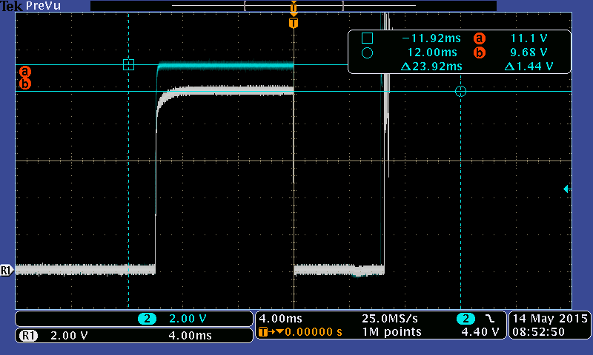

Figure 4: Open Load Detection Signal

After examining the schematics and narrowing the circuit down to the key components for open load detection, an outline can be achieved and seen in Figure 5.

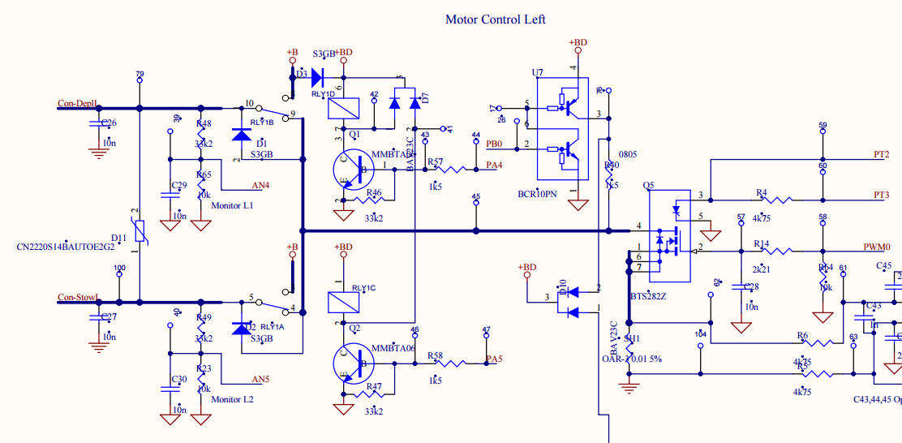

Figure 5: DRB Module Schematics, Open load detection circuitry outlined in red

A representative circuit can be developed, simplified, and segregated into the functional sections as shown in Figure 6 and expanded further to include the test stand circuits as shown in Figure 7.



Figure 6: DRB Controller Representative Circuit



Figure : DRB Controller with Test Stand Circuit

The test stand interface circuitry is low impedance and affects the measurement of the signals and may also affect the functionality of the DRB module. An analysis of one interface circuit, Deploy and Stow Signals, shows that given a worst case condition the voltage level seen by the test stand and the module will drop considerably. Figure 8 shows the conversion of the representative circuit into a condensed and simplified circuit to make it much easier to understand how the test stand circuit can affect measurements.



Figure : Interface Circuitry Analysis

Using the condensed circuit and assigning variables for the components we can get Equation (1) which is a simple voltage divider.

(1)

With some algebraic manipulation we can get to Equation (2) which will allow us to understand how to achieve a worst case tolerance stack-up.

(2)

Since the worst case is a minimum voltage and the relationship with the representative circuit is inversely proportional, the resistor values for R2 and R3 must be at the lowest limit while R1 must be at its highest tolerant limit.

(3)

Figure 4 shows the Deploy signal recorded with and without the test stand. It is easy to see the difference of voltage during the open load detection. The difference or Delta between the two signals during this phase is about 1.44V. It is important to note that the difference in voltage does not occur during the motor control portion of the signal. The reason for this is that portion in the DRB controller the does the open load detection has an extra resistor that can be seen in Figure 6. This resistor is also referred to in Figure 8 as R1.

The next step was to try and duplicate the conditions that cause the voltage difference in a simulation and compare that simulation to the actual measured value. The representative circuit was duplicated using Cadence PSpice and most of the functional part can be seen in Figure 9.

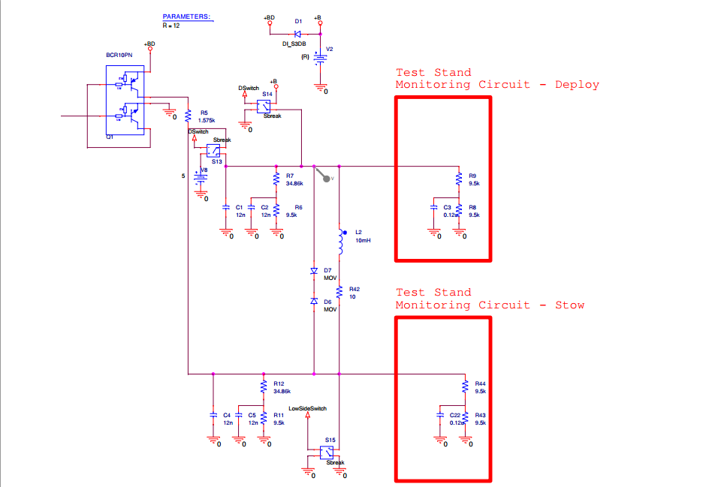

Figure 9: DRB Module Simulation Schematics, Test Stand Circuitry outlined in red

Deploy Voltage without monitoring circuitry

Deploy Voltage with monitoring circuitry

~1.446Vdc Δ

Deploy Voltage without monitoring circuitry

Deploy Voltage with monitoring circuitry

~1.44Vdc Δ

Figure : Scope Vs. Simulation

*Modularizing Project Hardware*



Figure : Modular Test Rack Concept